**OFFENSE MANAGEMENT SYSTEM** (DESKTOP APPLICATION)

MODULES (w/ details)

1. To develop a module that will allow the user to input offense records of students.
2. To develop a module that will automate the recording of the following offenses.

* To develop a module that will record Tardiness as a minor offense.
* To develop a module that will record violation of Curfew Policy
* To develop a module that will record Truancy as a major offense.

*-the automation of the recording will be through the RFID turnstile that the schools use, all three offenses will be time based (Turnstile log records will be utilized here.)*

1. To develop a module that will allow user to search, filter, and view information of all recorded offenses.
2. To create a database to store all records and information of offenses.
3. To develop a module that will send a notification to the OSS and parent/guardian of a student who committed an offense. (GSM module)

* *It’s still a decision whether to use AT commands with direct GSM modem com port or to integrate GSM in the Java system with Arduino.*

**Key points to do.**

* + - 1. Limit the number of users to 4 (CD, SHD, JHD, GSD) and the privileges of each users.
* Each users of specific department can view offenses of any student regardless of what department the student belongs to.
* Users input of offenses will only be limited to his/her specific department

(e.g. The SHS disciplinary office cannot record an offense of a students from department namely the (CD, JHD, & GSD).

* + - 1. Take not that, each department has different list of offenses and different penalties that comes along with the offense. (example, CD has no tardiness offense due to schedules of classes)
      2. Change the mode of input of offense.

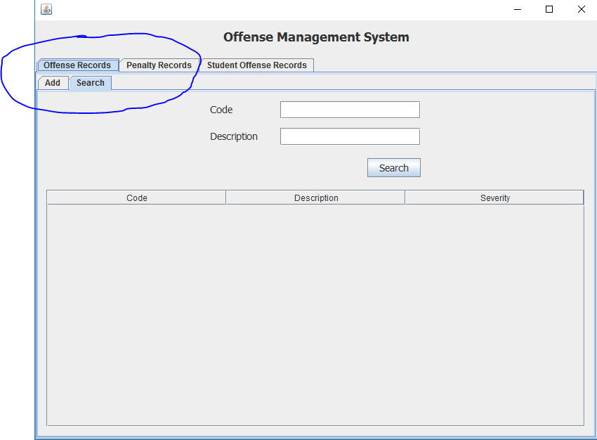

* Make “Offense Records” & “Penalty Records” Adding as one.

Example:

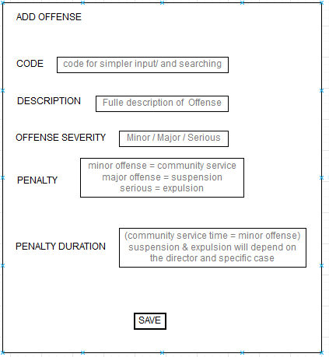

* + - 1. Overwrite existing offense with new if user desires to alter the offense rule.
* Let the code for each offense be unique. (1,2,3,4,5,….) increment?

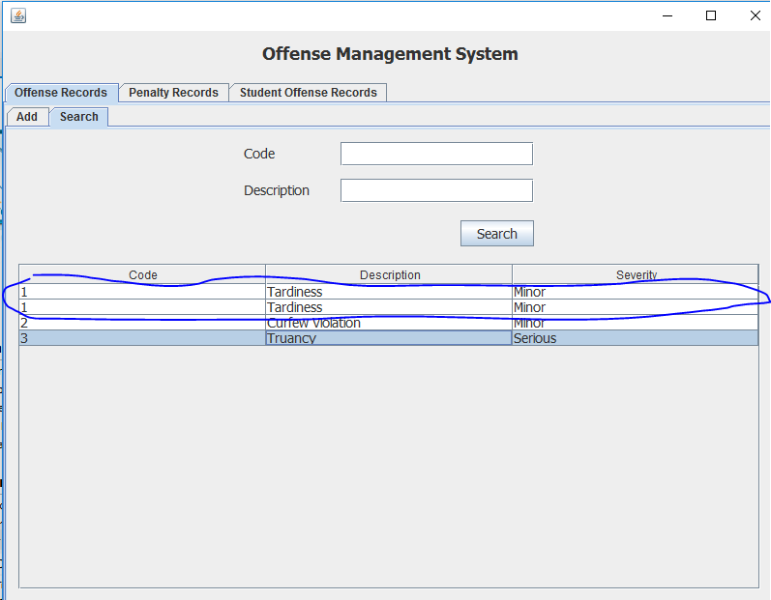

* + - 1. Create a fixed sample set of students for this prototype . This is because the system will utilize the student record database of the school in the future.

* Student info to be included.

* NAME (EX: HANS MICHAEL LIM)

* ID NUMBER ( EX: 150561

* DEPARTMENT (EX: CD,SHD,JHD,GSD)

* YEAR (EX: G-11)

* SECTION (EX: A)

* PARENT GUARDIAN CONTACT NUMBER (EX: 09773188802)

* (picture of a student for the profile)

* + - 1. Recording an Offense.

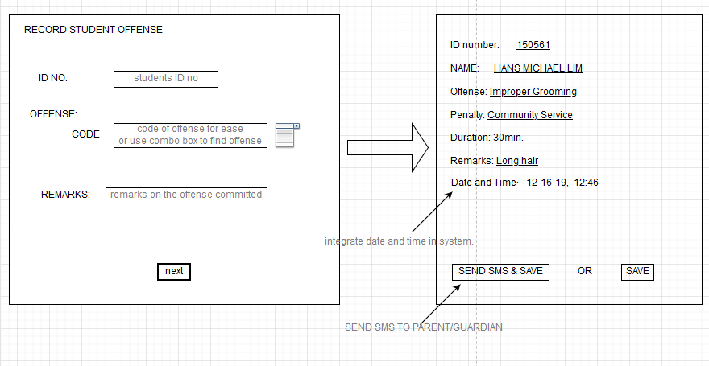

* + - 1. Sending an Offense. Message format will be preset and will only be filled with the following data.
* ID number
* Parent/guardian contact number
* Severity of offense (major/minor/serious)
* Offense description
* Penalty (comm service/ suspension/ expulsion)
* Duration for community service
* Remarks

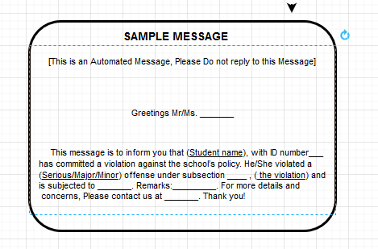

* + - 1. Searching for Specific Student and offense
* First column of the table will be the code for the offense
* Input timestamp (date and time of recorded offense)
* Total existing unserved community service and create a feature that allows the user to subtract the community service time.
  + - 1. 